LLD : Parking Slot

**Introduction**:

· We can use here the array data Structure (array : full Array , Empty Array)

· Full Array contains the slots which have parked vehicle

· Empty Array have all slots available

**Working :**

· When the vehicle comes slots will be provided from Empty Array and then after getting the information it is pushed in Full Array.

· When the vehicle leaves the slot, slot will be poped from Full Array and pushed it to Empty Array.

**Flow Diagram:**

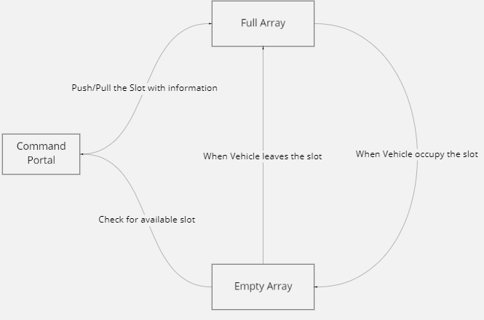

**Entities of System:**

| **Class** | **Method** | **Working/Uses** |
| --- | --- | --- |
| **Vehicle** | getVehiceNumber,  getvehicleColor | Used to get the vehicle number or set the number and color. |
| **Parking slot** | Slotnumber,slotIsempty,  slotVehicleNumber | Gives us the parking slot related information |
| **parking** | getparkingSlot | Gives us the slot number which is empty |
| createParking | Increase the size of ParkingArray |
| parkVehicle | Add the slot in full array with the related information |
| leaveParking | Add the slot in empty array |
| Status | Gives us the slots available in empty array |
| getVehicleNumberByColor | Gives us the vehicle number whose color matches from full array |
| getSlotsByVehicleNumber | Returns the vehicle number from full array |
| getSlotsByVehicleColor | Returns the vehicle color from full array |